IFS-6560T4-N

MANUAL OF 2.5A FOUR AXIS OF STEPPER MOTOR
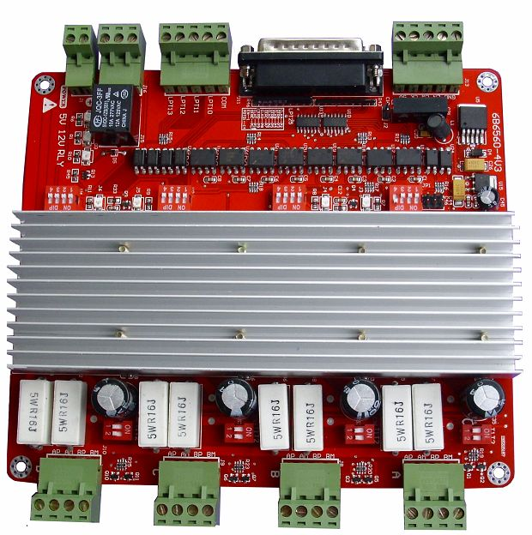

CONTENT

I、SUMmARY 1
II、THE ADVANTAGES OF TB6560HQ 3
2.1、ADVANTAGESAT LOW SPEED 3
2.2、ADVANTAGESAT HIGH SPEED 4
III、bRIFE performance OF IFS-6560T4-N 5
IV、GENERAL DIAGRAM 6
V、DEFINTION ON PINS OF PARALLEL PORT 7
VI、ADJUSTMENT ON CURRENT DAMPING,SUDIVISION,CURRENT OUTPUT 8
6.1、ADJUSting CURRENT DAMPING 8
6.2、ADJUSting SUBDIVISION 9
6.3、ADJUSTing CURRENT OUTPUT 9
VII、CONNECTION OF STEPPERMOTOR 10
VIII、CONNECTION OF LIMIT SWITCH 11
IX、CONNECTION OF 4TH AXIS EXTENDED 12
X、MATCH WITH DRIVE BOARD AND MOTOR 12
XI、USE METHOD OF MACH3 14
11.1、STARTup Mach3 14
11.2、BASIC SETTING OF mach3 16
11.3、SETTING OF mach3'S SWITCH 19
11.4、RUNNING OF G CODE 20
11.5、HOW TO SET THE CONTROL INTERFACE OF MACH3 23
XII、CONTACT US 23

I. Summary
The computer engraving machine is a new set of engraving and milling. The machine is mainly suitable for processing a variety of colorful patterns mould, such as,matrixes for embossing,sole mould,button mould,Zipper model,Stamping die design and die text,Instrument Mould,glass mold,etc.Also applies to advertising, such as logo of firms,scutcheon,module of building,badge,name-plate,panel,association's, emblem,door-plate,destination,board,decoration,upholster,etc. And applies for graphic engraving,Yin wen and Yang wen profile, and relief sculpture,such as portrait,scenery,Calligraphy Lettering,seal,etc.
The company's 4-axis Engraving machine drive will composed minimum control system, using high-performance special micro-step control of TB6560 chip , open micro-computer control according to user requirements to functional design to the driver board.The control panel suitable for driving any small or four-phase or two-phase hybrid stepping motor. And have 4 files adjustable features of current 0.6A, 1.2A, 1.8A, 2.5A , support MACH2, MACH3 ,KCAM4 Series software,Widely used in mold processing, graphic sculpture. As a result of new bipolar constant-current chopping technique, high precision, the motor running,with small vibration, low noise, smooth operation, safe and convenient, it is welcomed by the vast number of DIYers and engraving machine manufacturers.

II、The advantages of TB6560AHQ

1、The advantages at low speed
Low-speed operation system means clock frequency is not high, a small current drive based , such as several to 100 rpm, under the conditions of the user, in such applications will increase in costs such as using the traditional driver, either due to integrated chip subdivision is too low, leaving the low-speed vibration is too large; either had to choose a high drive segments.
The advantages of TB6560AHQ
- low vibration and noise.Because the chip comes with an optional sub-2,4,16, enough to meet speed nearly a few to high speed.
- Less heat:Large enough to heat the chip comes with a separate support the cooling requirements of small current drive
- Supports a variety of stepper motor:Customers can choose slightly larger moment of a hybrid or permanent magnet stepper motor, the motor work in the allowed peak torque between 30-50 percent, the motor costs almost the same; the chip set to provide more current file and current decay model, support various parameters under thethe same power index .

2、The advantages at high speed
High-speed operation system means clock frequency is higher, and a large current drive-based. Such as speed close to thousand rpm, under this application,compare with traditional driven program,Either due to integrated chip segment is too low, leaving the system is too small speed range,Either due to excessive breakdown and increase high costs, may also caused by high torque decrease vibration and noise.
The advantages of TB6560AHQ
- Low vibration and noise.As the chip TB6560AHQ comes with 16 segments, meeting nearly from a few to thousand rpm. and generates automatically a pure sine wave control current,compare with another highly integrated chip, the high torque at the same speed will not only not decreased, but increased..As TB6560AHQ can withstand the peak driving voltage 40V, 3.5A peak current, it provides continuous technical support.when the motor torque in a large, high-speed operation.
- Supports a variety of stepper motor.Customers can choose a hybrid moment slightly larger or permanent magnet stepper motor, in the maximum torque of between 30-50%, the motorthe costs is almost the same. The chip provide high current set and multi-profile current decay mode, support the same power index of the various parameters under the stepper motor.
- Less heat.The embedded drive compact, easy to heat.When it drive in high current , the chip surface to facilitate the external cooling radiator, the user can be also directly connected to the metal shell of the original controller,
In short, because TB6560AHQ is highly integrated, the external circuit is very simple, it is high reliability, and support 57 and some 86 per minute stepper motor from a few dozen to thousand rpm.in the wide speed application development and enable the both costs down of numerical control equipment and production

III、Brief performance of IFS-6560T4-N
We have accumulated many years of design experience in 4-axis engraving machine drive. And developed this type of TB6560T3V1.In addition to its main features a little bit above 6560, it also has:
- Driving four 2.5A stepper motor simultaneously,With 5-axis expansion, if you need to extend it
- Isolated completely high-speed DCDC optocouplers and protect your Pc.
- Spindle relay output, if you use the mach3 to control spindle start and stop
- Semi-flow control ,when the motor stop, current is reduced to the minimum stop effectively.
- The interface with the fans, you can add any fans
- With 4-way 0.8-3.5A (peak) adjustable current, rated output two-phase bipolar stepper motor driver
- Interface with Standard parallel port , support MACH2, KCAM4 series software.
- Limit interface with 4-ways, Plug connector designed fby connecting limit switches as you like
- Support four running mode,such as mixture,fast,low,normal mode.
- Support the choice of four segments - 1,1 / 2,1 / 4,1 / 16
- Stability,and small heat,24-36V single power supply input with switching power chip supply 5V power

IV、GENERAL DIAGRAM
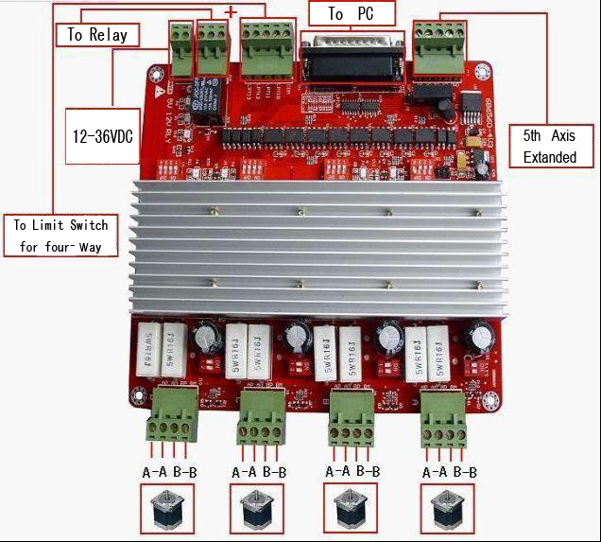

Fig 1

V、Definition on pins of parallel port
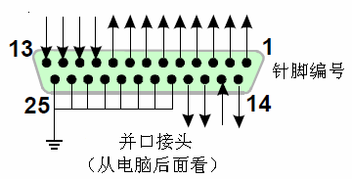
Fig2
25-pin parallel port control is defined as follows：
DB25(PIN) | The role of the pin on driver board | Notes
1 | EN | Enable all axis
2 | STEPX | X pulse signal
3 | DIRX | X direction signal
4 | STEPY | Y pulse signal
5 | DIRY | Y direction signal
6 | STEPZ | Z pulse signal
7 | DIRZ | Z direction signal
8 | STEPA | A pulse signal
9 | DIRA | A direction signal
10 | LIMIT-1 | Limit input1
11 | LIMIT-2 | Limit input2
12 | LIMIT-3 | Limit input3
13 | LIMIT-4 | Limit input4
14 | Relay control
15 | blank
16 | STEPB- | B pulse signal
17 | DIRB- | B direction signal
18-25 | GND

VI.Adjusting current decay,subdivision,current output
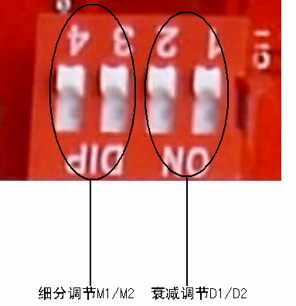
Fig 3

6.1、Adjusting current decay
The specific role of the current decay of stepper motor driver board:
Subdivision is now a way of the current subdivision of stepping motor, phase current according to sine wave is about to get the current point as the tangent point of breakdown. Subdivision in the phase current reaches the point of control is necessary to control current decay, otherwise there will overshoot the angle will not stay in the exact breakdown point.Motor at different speeds, selected for different decay modes.fast decay ad high speed,slow decay at low speed.Slow decay occurs when high-speed vibration, noise, Low speed at fast decay will lead motor weakness, severe cases are not allowed to locate. Motor Control IC for the current decay of the H bridge switches is the control mode.The high side of the tube when the slow decay off, fast decay tube are closed when the high and low side. Mixed decay is the fast decay first and then a slow decay, mixing ratio of decay time and power for the chip also will be different.
Marked on board D1/D2 ,the value of the current decay is set DIP switch
D1/D2 correspondence between the location and decay mode, following table

DIP D1 | DIP D2 | Running mode
ON | ON | Fast decay
OF | ON | 50% decay
ON | OF | 25%decay
OFF | OFF | Slow decay

6.2、Adjusting subdivision
You may adjust the subdivision mode of board, DIP switches on the two on the M1/M2 adjust DIP switch，DIP switch location and subdivision mapping table below
DIP M1 | DIP M2 | Subdivision mode
OFF | ON | 1/16
OFF | OFF | 1/4
ON | OFF | 1/2
ON | ON | 1
To make the motor run smoothly, please try to choose high segments, such as 1 / 16 segments

6.3、Adjusting current output
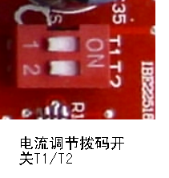
Fig 4
Current standard T1/T2 by two board DIP switch to adjust,T1/T2 location and value of current output, correspondence as follows:
DIP T1 | DIP T2 | Value current
OFF | ON | 25%*2.5A
ON | ON | 50%*2.5A
ON | OFF | 75%*2.5A
OFF | OFF | 100%*2.5A
We proposed the current value closed to rated of stepper motor

VII、Connection of stepper motor
Electrical connection diagram refer to the overall wiring diagram IV：

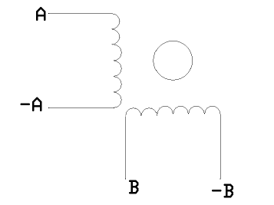
Fig 5
Four-wire stepper motor connection
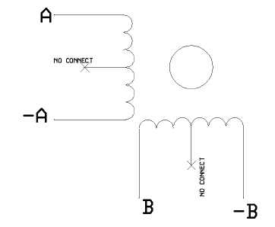
Fig 6
Six -wire stepper motor connection

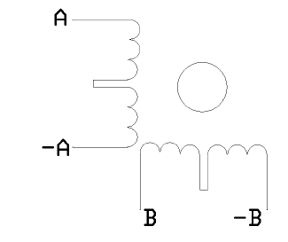
Fig 7
Eight -wire stepper motor connection
Notes:Motor A,-A, B,-B, connected respectively, connected driver board AP, AM, BP, BM

VIII、Limit switch connection
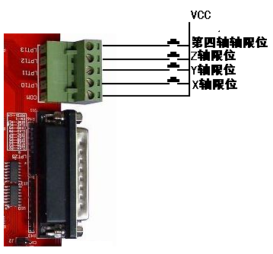
Fig 8

IX、The 4th axis extended connection
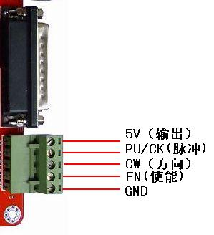
Fig 9

X、 Match with the and driver board
The panel of IFS-6560T4-N four-axis match with two and four-phase motor drive of domestic and foreign manufacturers. In order to obtain the most satisfactory results, need to set a reasonable supply voltage and current. The high-speed performance depends on the degree of the motor supply voltage.but the current set value determines the output torque of the motor.
1、Select supply voltage
In general, when the higher the supply voltage, more great torque at the motor high speed, and avoid the motor out of step at high speed.. On the other hand, the voltage too high may damage the drive, and work in high-voltage,vibratory at low speed Reference value of power between 12-36VDC 8A
2、Set value of output current
The larger of setting current, the greater of output torque in the same motor. But the problem is the larger current the more heat of motor and driver. So in general,we set the value at when it warm but not too hot on running at long-term.
- At high speed mode of 4 and 6-wire: the output current equal or less rated value
- Larger torque mode of 6-wire: output current is 70%of rated value.
- Ttandem-type connection of 8-wire:output current is 70%of rated value
- Parallel connection of 8-wire:output current is 1.4times of rated value.
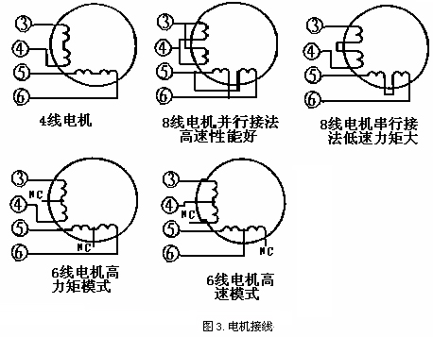
Notes: please operating motor 15-30 minutes when you finished the setting of current.If the motor temperature is too high, you should reduce the value. If reducing the current value, the motor output torque is not enough to improve the cooling conditions, are invited to ensure motor and drive are not hot.

XI、Usage of MACH3

11.1、Startup Mach3
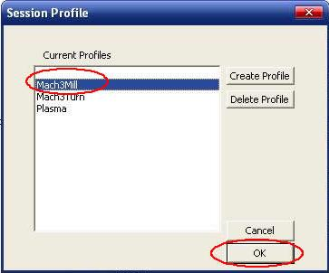
Fig 11 open mach3
When you have installed the software, here are 3 icons on the desk,let's click the march3Mill, as fig 11.
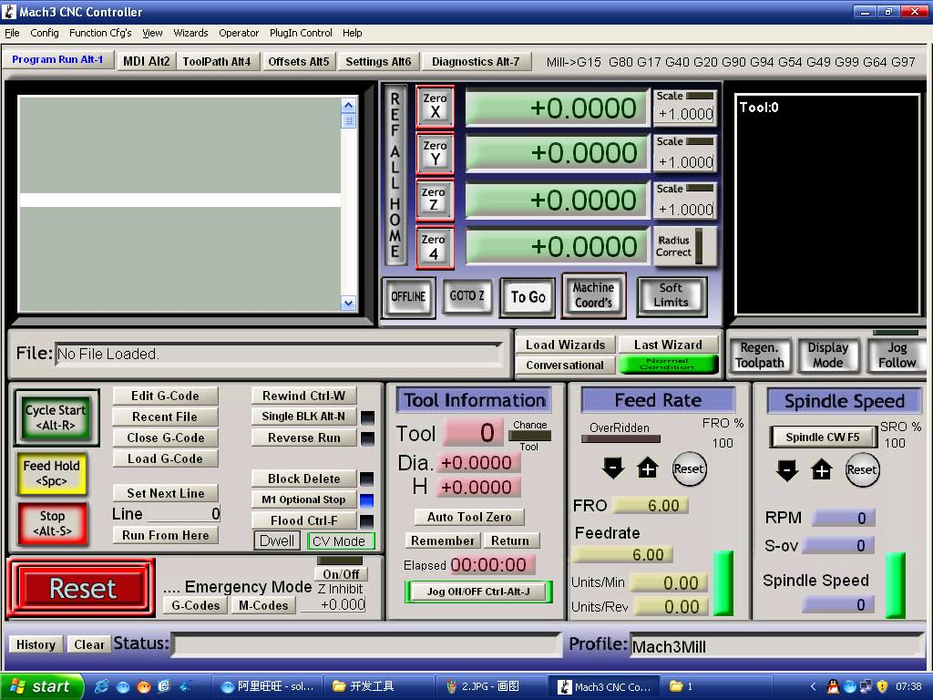
Fig 12 the main interface of march3
The main interface of MACH3 as fig 12 ，some basic buttons on it,Here, we first configure MACH3.
11.2、The basic set of mach3
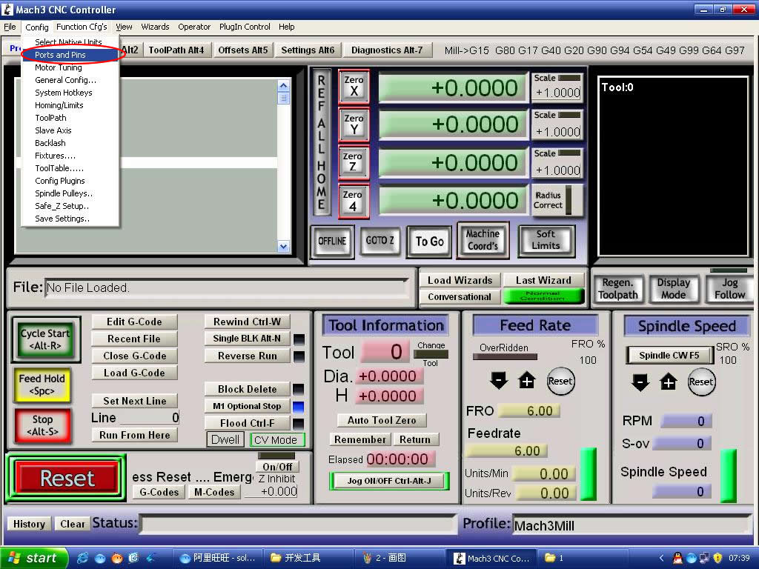
Fig 13 set menu of mach3
Open the config menu, ports and pins menu, marked with red circlet

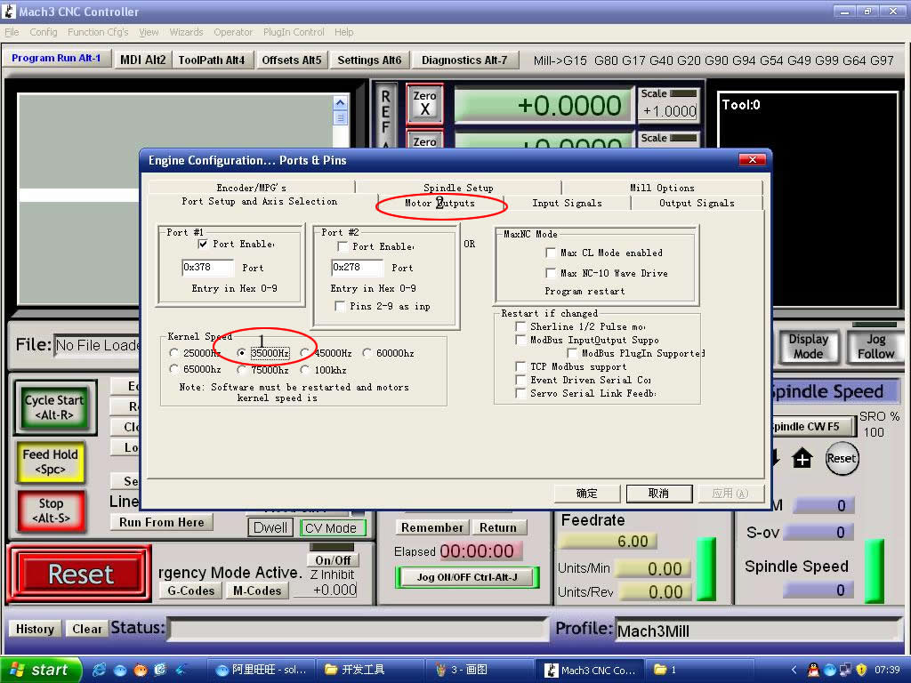
Fig 14 The basic frequency setting
Circlet1, where you can set the fundamental frequency, this parameter is the speed of motor rotation. After setting the place chosen circlet 2, there shown in Figure 15, the following us direction and pulse settings:
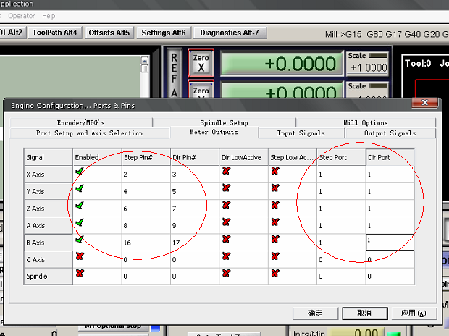
Fig 15 basic setting of direction and pulse pins
When you finished the setting, click output signals then set ENABLE and Relay
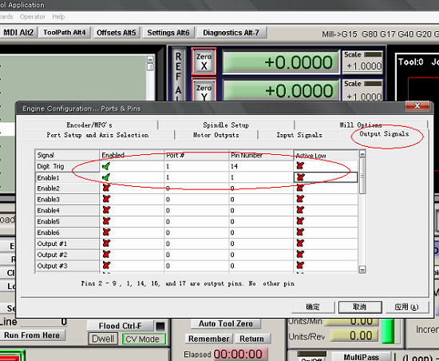
Fig 16 setting the ENABLE and Relay's pin

11.3、Adjusting limits witch of mach3
Click input signal，the parameter as fig17
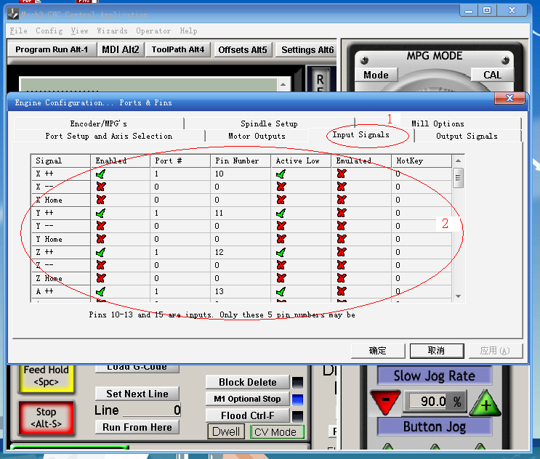
Fig 17

11.4、Running of G code
G is the numerical instructions control program code , mach3 for customers to test software comes with the G code, you can easily test machine.click the File，as fig 18

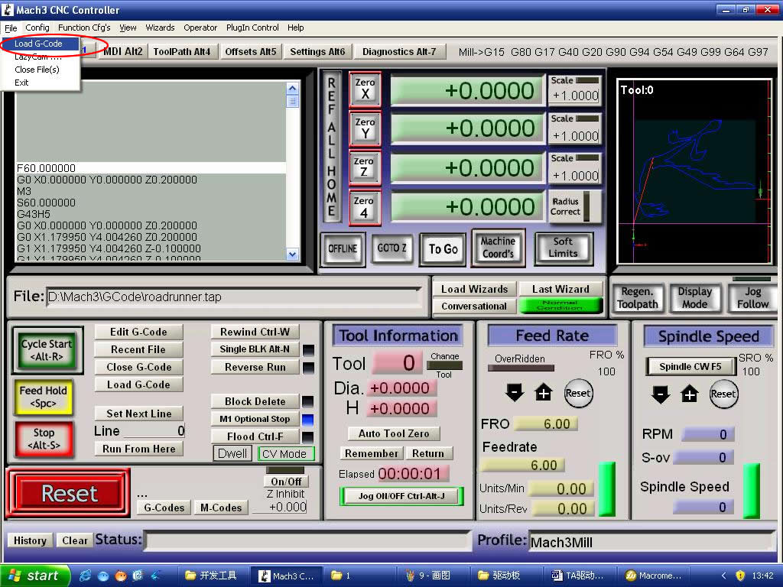
Fig 18 Open G
Click the red circlet Load G-code and open the iconand click ,and choice a G code, the interface as follows as fig 19

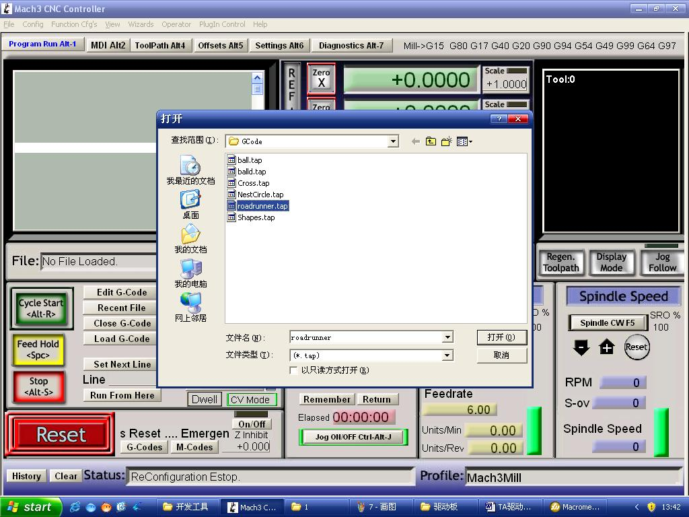
Fig 19 Open the testing procedures of G
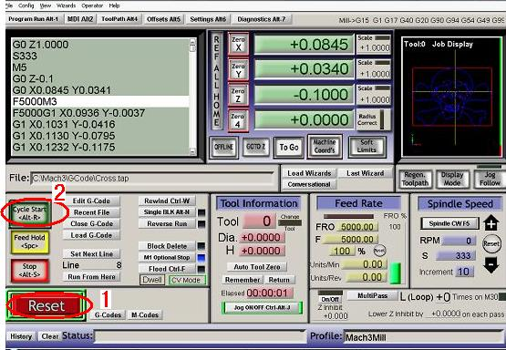
Fig 20
When you open the G code, you may watch on a flashing red button RESET, click it to stop, and click the CYCLESTART.
If you want to run your own G code for processing.find your location of G code, and leading it in.，

11.5、How to use the manual control interface of MACH3
If you want manual control, press the TAB as follows as :
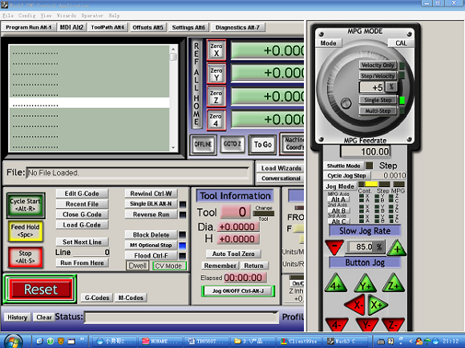
图11

